Gateway Design Document

Project name : CCS System

Project ID : 2011716

Author :

Document ID

Version :

Date :

Status

Classification :

|  |  |  |  |
| --- | --- | --- | --- |
| Name Reviewer(s): | Function Reviewer(s): | Review date: | Signature: |
| *Kevin Song* |  |  |  |
|  |  |  |  |
| Name Approver | Function Approver | Approval date: | Signature: |
| Georgio Mosis |  |  |  |

|  |  |  |  |
| --- | --- | --- | --- |
| Document history | | | |
| Version: | Date: | Author: | Reason |
| *0.1* | *03-08-2015* | *Raymond Qin* | Initial Gateway Design document |
| *0.2* | *10-08-2015* | *Kevin Song* | *Update structure and details* |
|  |  |  |  |
|  |  |  |  |

1 Introduction 3

1.1 Purpose 3

1.2 Scope 3

2 Requirements 3

2.1 Context 3

2.2 Design Constraints And Assumptions 4

3 System Architecture 5

3.1 System Architecture 5

3.2 System Process 6

3.2.1 Activity Diagram 6

3.2.2 Technical Approach 6

4 Detailed Design 7

4.1 Class Diagram 7

4.2 Sequence Diagram 8

4.3 Business Component 8

4.4 Security Management 9

5 Interfaces 9

5.1 Interface Overview 9

5.2 Interface Detail 9

6 Miscellaneous 9

Skills/Tools 9

Distribution list 10

# Introduction

## Purpose

This document describes the System Architecture of Gateway Server, and include detailed design for core modules.

## Scope

This document mostly focus on Gateway Server Architecture Design, and also include CCS System and P-Broker related modules.

# Requirements

## Context

CCS System is running on AliCloud, it need communicate with PKU1 clinical systems in almost real-time, Gateway Server will take up the responsibility of bi-directional data synchronization between CCS System and PKU1 clinical systems.

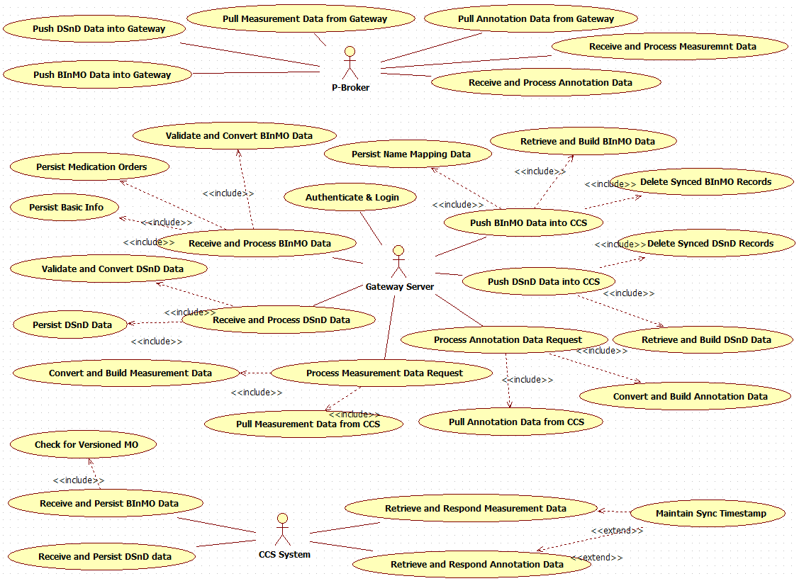

Use Case Diagram

## Design Constraints And Assumptions

* Due to Security consideration, Gateway Server can`t raise any request to PKU1 inner systems.

It means all the business requests should be raised by P-Broker system.

* Gateway Server will also be restrict for internet communication, it will be restrict to access single IP of AliCloud CCS System.
* Gateway Server will be deployed in PKU1 Enviroment.

# System Architecture

## System Architecture

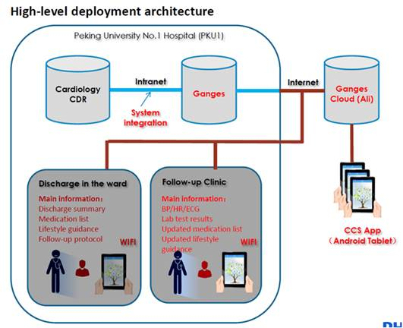

High-level Deployment Architecture

The Server named Ganges is Gateway Server, it will be deployed in PKU1 Enviroment, and be restrict for access due to security consideration.

Gateway Server communicates with periphery systems via Restful Web Service.

## System Process

### Activity Diagram

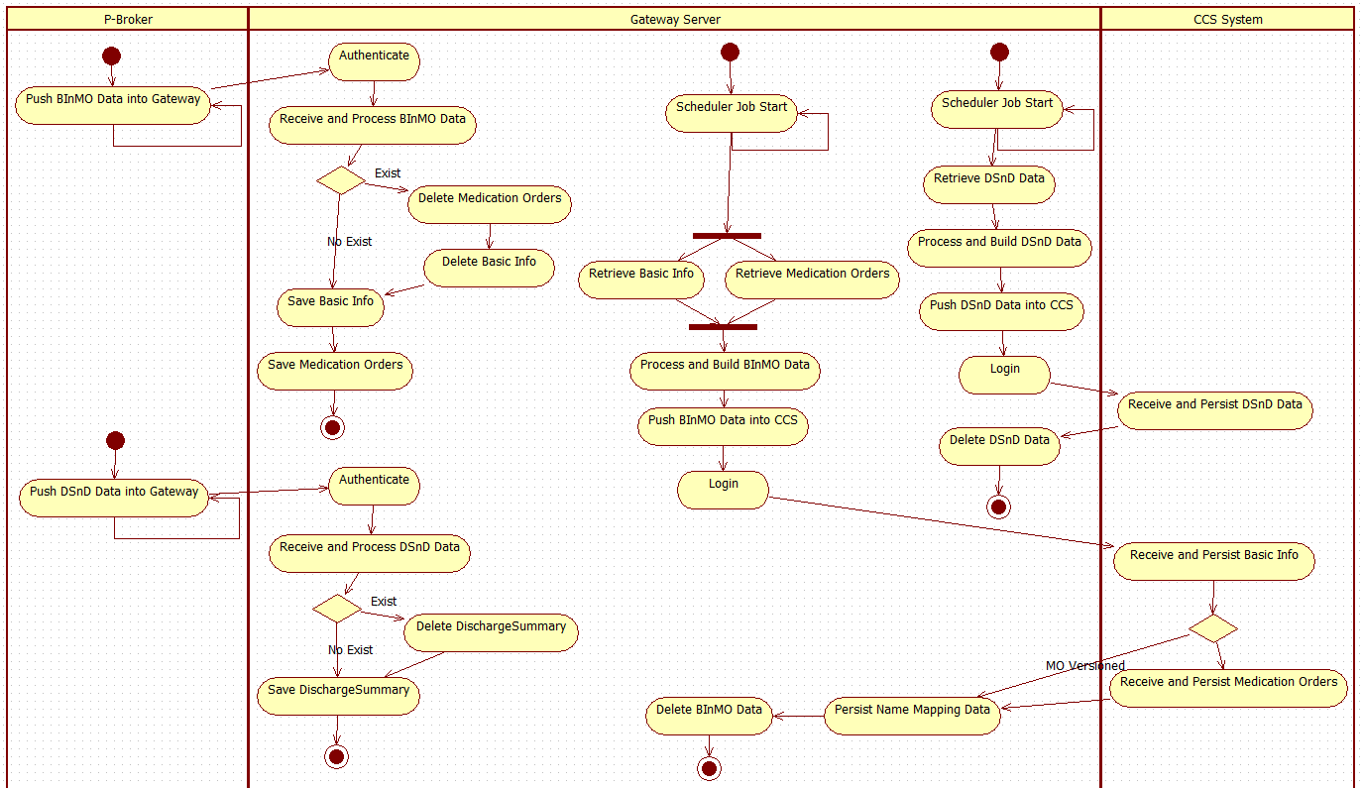

Inbound Data Activity Diagram

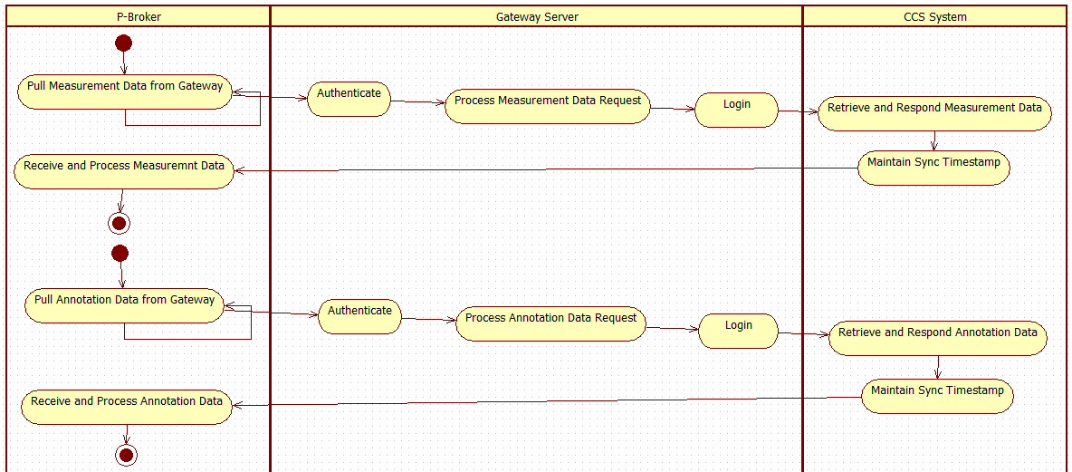

Outbound Data Activity Diagram

### Technical Approach

* Gateway Server communicates with periphery systems via Restful Web Service.
* Adopt DTO to encapsulate business data, control data, acknowledge data for transport.
* For all data sync requests, should be raised by PKU1 system periodically, time interval by default is 3 munites, and adjustable.
* For all requests, will provide proper response, exception information to acknowledge the result.
* All the Data will be synced incrementally, judged by sync timestamp.
* For Inbound data, first be persisted in Gateway Server Database, and then push to CCS System by scheduler jobs, to decouple the ecosystem.

# Detailed Design

## Class Diagram

Interface Data Model Diagram:

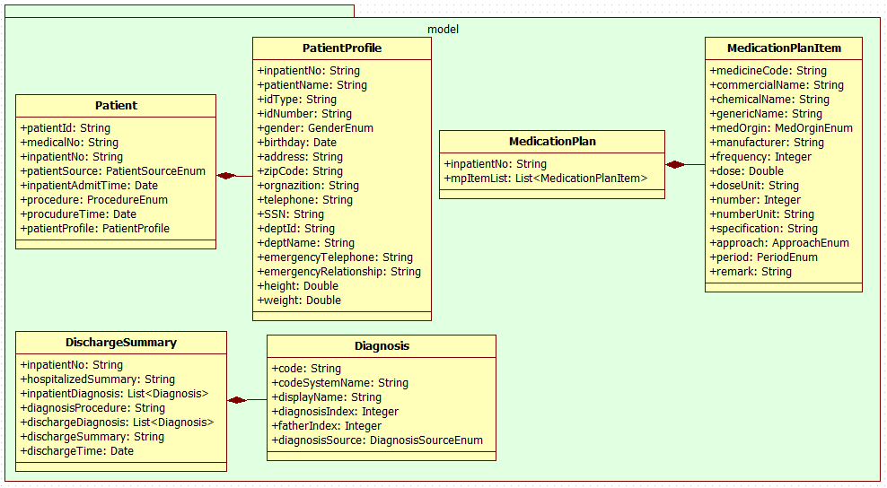

Interface & DTO Diagram:

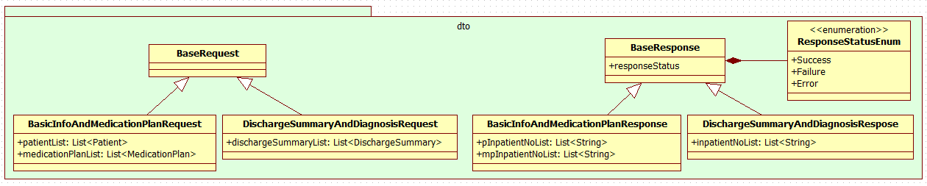

Logic Class Diagram:

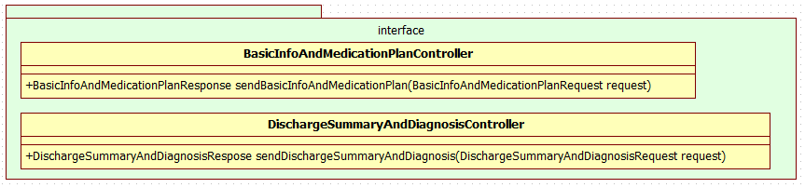

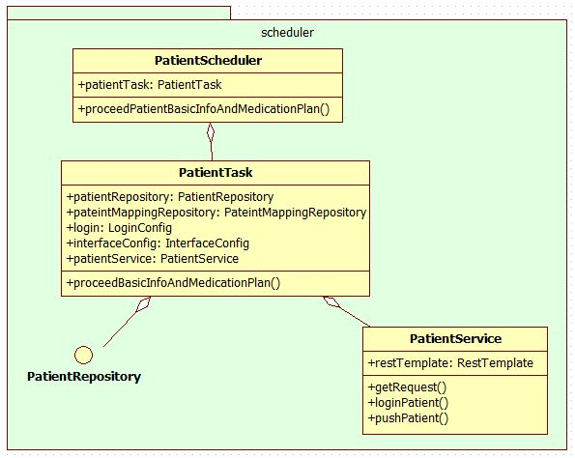

## Sequence Diagram

N/A

## Business Component

|  |  |  |
| --- | --- | --- |
| No | Description |  |
| Interface Data Model & DTO | Data Model & DTO aligned with PKU1 Clinical System Provider |  |
| CCS Data Model | Data Model compliant with CCS System |  |
| Repositroy | The application and mongo interactive interface |  |
| Controller | Interface exposed to invokers |  |
| Task | Scheduled Job to complete automation tasks |  |
|  |  |  |
|  |  |  |

## Security Management

Though Gateway Server will be deployed in PKU1 intranet, a proper security control is still required.

In Gateway Server security solution, both Server side and Client side will align a set of credentials, we will just verify credentials and then judge the legality of the requests.

# Interfaces

## Interface Overview

|  |  |
| --- | --- |
| **Resource** | **Description** |
| POST /v1/gateway/patients/basicinfos | Push Patient information and Medication Orders |
| POST /v1/gateway/patients/dischargesummaries | Push Discharge Summary and Diagnosis |
| POST /v1/gateway/patients/measurements | Pull Measurement information |
| POST /v1/gateway/patients/annotations | Pull Annotation information |
|  |  |

## Interface Detail

Please refer to Gateway REST APIs Document.

# Miscellaneous

The following skill sets are required to develop the Gateway Server.

|  |  |
| --- | --- |
| Skills/Tools | Java, REST Web Service, MongoDB, Spring, etc. |

Distribution list

Name Department Location